Saraswathi
  - API Design V1
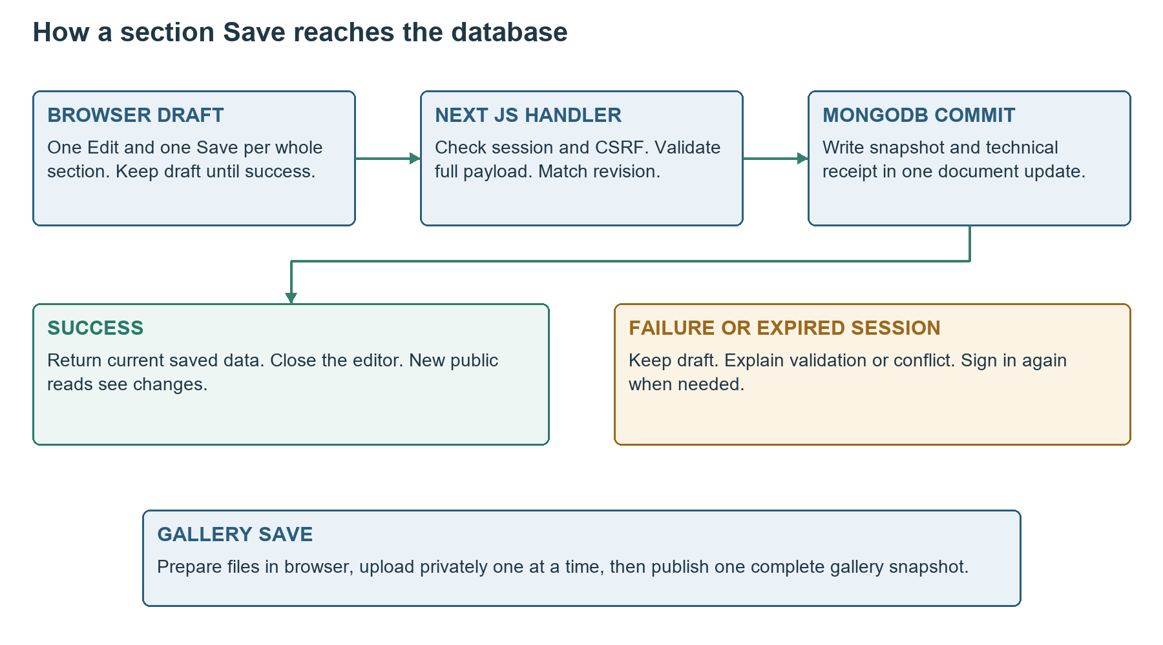
Figure 1 Browser interaction and the protected whole-section Save flow
Engineering specification for the Saraswathi Puja single page website. This document turns the agreed product behaviour into implementable contracts for the Next.js monolith, its sole administrator and public readers.
Document detail | Value
Version and date | 1.0 | 15 October 2026
Platform | React and Next.js on Vercel; separate MongoDB Atlas database
Celebration | 16 to 20 October 2026; main programme on 16 October
Audience | Frontend and backend engineers, reviewers and testers

1 API Conventions and Shared Types
Serve same-origin HTTPS endpoints under /api/v1 using Next.js Node.js Route Handlers. No separate backend deployment or public API key is needed. Initial Server Components can call shared server services directly; browser actions call these handlers. Both paths enforce the same domain validation. [A1]
Convention | Contract
JSON | application/json; UTF-8; reject unknown body properties
IDs | Lowercase UUID strings except fixed section keys
Money | Integer paise or null; never formatted strings or floating-point rupees
Dates | UTC ISO 8601 Z for instants; YYYY-MM-DD and HH:mm for local event values
Bilingual text | {en: string, te: string}; nullable pairs only where DB schema permits
Language | Return both languages; browser switches and searches locally
JSON body limit | 2,000,000 bytes; auth requests limited separately to 4096 bytes
Upload body limit | 3,400,000 bytes including multipart boundaries and thumbnail
Read caching | JSON content and auth responses use Cache-Control: no-store
CORS | No cross-origin allowlist; reject cross-origin mutations

1.1 Standard JSON envelope
{"data": {"example": "value"}, "requestId": "server-generated UUID"}

{"error": {
"code": "VALIDATION_FAILED",
"message": "Please correct the highlighted fields.",
"fieldErrors": [{"path": "value.households.0.amountPaise",
"code": "POSITIVE_INTEGER_REQUIRED"}]
}, "requestId": "server-generated UUID"}

requestId identifies a server attempt and is safe to show for support. It is not an idempotency key. Machine-readable codes remain stable; the page translates them into English or Telugu. Never expose stack traces, connection strings, tokens, password hashes or a submitted password in responses.
error.fieldErrors is optional. error.details is an optional object; REVISION_CONFLICT uses {currentRevision: integer}, and throttling uses {retryAfterSeconds: integer}. Validation truncation is error.truncated. No private snapshots are included in errors; fetch a protected current snapshot for review.

1.2 Snapshot types
AdminSnapshot is {scope, revision, updatedAt, value}. value is the public business data in the DB contract, without internal receipts or ownership. MutationResult is {snapshot, committedRevision, changed, replayed}. Section keys are welcome, announcement, programme, puja_prasadam, committee, venue and donation; chandas and gallery are separate scopes.

2 Endpoint Catalogue and Permissions
Method and path under /api/v1 | Access and purpose
GET /content | Public; all seven published content sections
GET /chandas | Public; complete household list, total and update time
GET /gallery | Public; published gallery metadata
GET /media/{mediaId} | Public only if currently referenced; variant query
GET /auth/session | Public session-state check; no private account fields
POST /auth/sign-in | Same-origin credential check; creates cookies
POST /auth/sign-out | Same-origin sign-out; CSRF required for an active session
GET /admin/sections/{key} | Admin; full editable section snapshot
PUT /admin/sections/{key} | Admin and CSRF; replace one entire section
GET /admin/chandas | Admin; full editable Chandas snapshot
PUT /admin/chandas | Admin and CSRF; save all household rows
GET /admin/gallery | Admin; full editable gallery snapshot
PUT /admin/gallery | Admin and CSRF; publish the full gallery draft
GET /admin/operations/{scope}/{operationId} | Admin; resolve a prior whole-section Save
POST /admin/media-batches | Admin and CSRF; open private upload batch
GET /admin/media-batches/{batchId} | Admin; inspect batch and uploaded file metadata
PUT /admin/media-batches/{batchId}/files/{clientFileId} | Admin and CSRF; upload one prepared file and thumbnail
DELETE /admin/media-batches/{batchId} | Admin and CSRF; abandon private batch, not public media

There is no household PATCH endpoint, per-photo publication endpoint, public upload, public signup, password recovery or payment-confirmation endpoint. Additions and deletions occur inside a full section draft and become public only through its Save. A UI Cancel normally makes no published-data request.
Unknown methods return 405 with Allow. Unknown paths or section keys return 404. Every /admin handler authenticates on the server before revealing private metadata. GET never changes published business content.

3 Public Content Chandas and Gallery Reads

3.1 GET content
No body or query parameters. Return 200 with data.sections mapping every section key to its published data object and data.media mapping referenced image IDs to public image descriptors. Section shapes are defined in Database Design chapters 3 and 4. Include null or empty values for genuinely unfinished content; do not invent samples. Return 503 on a failed database read.
{"data": {
"sections": {
"welcome": {"celebrationName": {"en": "...", "te": "..."},
"message": {"en": "...", "te": "..."}, "deviMediaId": null,
"startDate": "2026-10-16", "endDate": "2026-10-20",
"mainDate": "2026-10-16", "timezone": "Asia/Kolkata"}
}, "media": {}
}, "requestId": "..."}

This abbreviated example shows the welcome member only; the actual response always contains all seven section keys. Linked puja programmeEventId references are resolved to their current event title and time in the public representation, without changing the stored authoritative event.

3.2 GET chandas
{"data": {"currency": "INR", "households": [{
"id": "11111111-1111-4111-8111-111111111111",
"name": {"en": "Example Household", "te": "ఉదాహరణ కుటుంబం"},
"amountPaise": 150000, "status": "paid"
}], "totalPaise": 150000, "updatedAt": "2026-10-16T14:30:00Z"},
"requestId": "..."}

A Pending row has amountPaise null and status pending. Status is derived for this response, not stored independently. No name query or pagination is needed for this small loaded list. Browser search filters both spellings while retaining the overall total. A failed read must not become a successful empty list or zero total.

3.3 GET gallery
Return data.items in canonical newest-first order. Each item contains id, mediaId, caption BilingualText or null, alt BilingualText, publishedAt ISO instant and image descriptor. Descriptor is {mainUrl, thumbnailUrl, mimeType, width, height}. data.count equals items.length. Empty gallery is 200 with items [] and count 0. Never include binary bytes in these JSON reads.

4 Published Image Delivery

4.1 GET media by ID
Input or output | Contract
Path mediaId | Valid UUID; malformed ID returns 400
Query variant | main or thumbnail; defaults to thumbnail; reject other values
200 response | Raw image bytes, not a JSON envelope
Content-Type | Validated image/jpeg, image/png or image/webp
Content-Length | Actual selected variant byte length
ETag | Quoted SHA-256 digest for that immutable variant
Cache-Control | public, max-age=300, must-revalidate
Security headers | X-Content-Type-Options: nosniff; safe inline disposition
If-None-Match | After access check, matching ETag returns 304 with no body
Missing or private ID | 404 MEDIA_NOT_FOUND without distinguishing private staging

Public mainUrl is /api/v1/media/{mediaId}?variant=main and thumbnailUrl uses variant=thumbnail. Before serving bytes or returning 304, verify a current gallery or approved content reference. Existence alone is insufficient. Return one requested variant only; the main response is at most 3 MB. [A2]

4.2 Cache and removal behaviour
Replacing a photo creates a new media ID. A deleted or replaced file cannot be newly read from the origin once unreferenced, but a browser may retain its cached bytes for the five-minute freshness period or an already downloaded copy indefinitely. Physical deletion occurs later through safe private maintenance. Public media are not confidential assets.

4.3 Frontend behaviour
- Use thumbnail URLs in the gallery and lazy-load offscreen images.
- Request main only for enlargement; preserve its aspect ratio.
- Use a recoverable image failure state without breaking the page.
- Keep static labels and photo controls bilingual; media bytes do not change with the selected language.
Allow public image requests from normal browser image elements. Mutating endpoints remain same-origin protected. No third-party image storage URL or signed cloud-upload integration is part of V1.

5 Sign In Session and Sign Out Contracts

5.1 POST auth sign in
Require Content-Type application/json, an exact trusted same-origin Origin and an auth body of at most 4096 bytes. Do not require an existing session CSRF token for sign-in; same-origin checks and JSON-only parsing protect this entry. Reject cross-origin requests before credential processing. [A3]
Request: {"email": "organiser@example.com", "password": "<private>"}
200: {"data": {"signedIn": true,
"expiresAt": "2026-10-16T12:30:00Z"}, "requestId": "..."}

Normalise email by trimming and lowercasing; never trim or alter the password. Validate email length at most 254 and password input at most 128 Unicode code points and 512 UTF-8 bytes. Provisioning requires at least 12 characters. Verify the private scrypt hash; unknown email and wrong password both return 401 INVALID_CREDENTIALS with the same message.
On success generate independent random session and CSRF tokens. Set __Host-saraswathi_session as Secure, HttpOnly, SameSite=Strict, Path=/, no Domain; __Host-saraswathi_csrf is identical except readable by site JavaScript. Expiry is exactly three hours, with Max-Age=10800. Store only token digests in the session record. Rotate/revoke the prior current-browser session on a new sign-in. Do not return tokens in JSON or store them in localStorage.

5.2 GET auth session
200 signed out: {"data": {"signedIn": false, "expiresAt": null},
"requestId": "..."}
200 signed in: {"data": {"signedIn": true,
"expiresAt": "2026-10-16T12:30:00Z"}, "requestId": "..."}

Missing, revoked or expired session returns signedIn false and clears stale cookies where possible. A database failure is 503, not a signed-out result. Do not expose email, password parameters or a session digest. This endpoint never renews expiry.

5.3 POST auth sign out
Send {} and, when an active session exists, X-CSRF-Token. Enforce same origin. Delete the current session and clear both cookies with Path=/ and Max-Age=0. Return 200 with data.signedIn false. An already absent or expired session returns the same result; no public content is changed. If revocation cannot be confirmed, return 503 and do not claim successful server sign-out.
Five failed credential attempts in a 15-minute IP bucket cause 429 SIGN_IN_THROTTLED and Retry-After seconds. Use the shared DB counter. Account setup and controlled credential replacement are private operational procedures, with no public signup or recovery route.

6 Admin Reads and Whole Section Saving

6.1 Protected editing snapshots
GET /admin/sections/{key}, GET /admin/chandas and GET /admin/gallery return 200 with data as AdminSnapshot. Authenticate before returning any snapshot. These reads use no-store and do not require a CSRF header because they do not mutate data. For linked puja entries, the editable value retains the storage representation and reference ID.
{"data": {"scope": "announcement", "revision": 0,
"updatedAt": "2026-10-15T04:30:00Z", "value": {
"state": "pending",
"message": {"en": "Annadanam date will be announced shortly.",
"te": "అన్నదానం తేదీ త్వరలో ప్రకటించబడుతుంది."},
"eventDate": null, "eventTime": null, "venueNote": null
}}, "requestId": "..."}

6.2 PUT admin sections by key
Require active session, exact Origin, application/json, X-CSRF-Token matching the session-bound CSRF cookie digest and Idempotency-Key UUID. Read that cookie immediately before each mutation because another tab can sign in and rotate it. Path key must be one of the seven allowed content section keys.
{
"expectedRevision": 0,
"value": {
"state": "confirmed",
"message": {"en": "Annadanam details confirmed", "te": "వివరాలు ఖరారయ్యాయి"},
"eventDate": "2026-10-21", "eventTime": null, "venueNote": null
},
"mediaBatchId": null
}

value must be the complete exact section data object from the DB field dictionary. mediaBatchId is required as null when no new files are referenced, otherwise a valid batch UUID for this scope. Omitted required fields are errors, not implicit deletion or defaults. Arrays include every retained entry. Removal is omission from the explicit full array.

6.3 Save result and validation
Return 200 with MutationResult. snapshot.value contains canonical business content; committedRevision identifies this operation. Unknown fields, missing bilingual pairs and invalid relationships produce 422 with field paths. A stale revision returns 409 REVISION_CONFLICT and currentRevision. Programme and puja_prasadam saves use the shared transaction guard described in DB Design; reject referenced-event deletion with 409 LINKED_CONTENT_CONFLICT.

7 Whole Chandas Save Request
PUT /api/v1/admin/chandas is the only contribution mutation endpoint. One click submits all rows, including rows hidden by the current search. Require the protected mutation headers and Idempotency-Key. Load a complete AdminSnapshot before opening the editor; do not build a draft from a filtered public list.
Headers:
Content-Type: application/json
X-CSRF-Token: <current readable CSRF cookie value>
Idempotency-Key: 77777777-7777-4777-8777-777777777777

{
"expectedRevision": 3,
"value": {
"currency": "INR",
"households": [
{"id": "11111111-1111-4111-8111-111111111111",
"name": {"en": "Example Household", "te": "ఉదాహరణ కుటుంబం"},
"amountPaise": 150000},
{"id": "22222222-2222-4222-8222-222222222222",
"name": {"en": "Another Household", "te": "మరో కుటుంబం"},
"amountPaise": null}
]
},
"confirmedClearIds": [],
"confirmedRemovalIds": []
}

7.1 Amount entry and clearing
The page converts an entered INR amount to integer paise before transfer. INR 1500 becomes 150000, replacing the old household amount. It never means add INR 1500. For a family that gave INR 1000 and later INR 500, the organiser enters INR 1500. The server stores only that current total and recomputes the overall total.
Null means Pending. Reject zero, negative, fractional paise, numeric strings and unsafe integers. If a currently recorded amount becomes null, its ID must be in confirmedClearIds. If a household with a recorded amount is omitted, its ID must be in confirmedRemovalIds. Confirmed IDs must refer to actual corresponding changes; do not accept a blanket confirmation boolean.

7.2 Additions and capacity
A new household has a new UUID generated for the draft and two reviewed spellings. Removing a Pending household needs no paid-amount confirmation. Duplicate names can coexist; duplicate IDs cannot. Retain at most 1000 households and reject payloads above 2 MB. Do not send totalPaise, status, updatedAt, updatedBy or recentCommits in the request.

8 Chandas Save Result and UI Behaviour
200:
{"data": {
"snapshot": {"scope": "chandas", "revision": 4,
"updatedAt": "2026-10-16T14:30:00Z",
"value": {"currency": "INR", "households": [{
"id": "11111111-1111-4111-8111-111111111111",
"name": {"en": "Example Household", "te": "ఉదాహరణ కుటుంబం"},
"amountPaise": 150000
}], "totalPaise": 150000}},
"committedRevision": 4, "changed": true, "replayed": false
}, "requestId": "..."}

This response example abbreviates the household list; actual success returns the complete canonical list. Public status labels are derived from the returned amounts. No-op saves return changed false and preserve the prior revision and timestamp. A replay returns replayed true without applying another update.
Outcome | Page behaviour
200 confirmed | Replace the whole Chandas view, total and timestamp; close editor
422 invalid row | Keep all drafts; highlight fields by household path and stable ID
401 session expired | Keep draft; open sign-in; require a new explicit Save afterward
403 CSRF rejected | Keep draft; refresh session state and request sign-in if needed
409 stale revision | Keep draft; show newer data is available; require review
Network failure or 503 uncertain | Keep operation key and original payload; resolve status before retry
Cancel | Discard local changes after confirmation when dirty; no Chandas write

8.1 No row-level Save controls
All household rows become editable through one Chandas Edit control. One Save and one Cancel apply to the whole list. Search can hide rows without removing them from the draft. Disable duplicate submissions while saving; do not close the editor merely because the request was sent.

8.2 Timestamp and public refresh
Advance the update label only for a committed household or amount change. Gallery, programme and unrelated edits do not affect it. Display the server timestamp in India time. Existing visitor tabs obtain changes on a subsequent read or refresh; no WebSocket or automatic payment verification is introduced.

9 Idempotency and Operation Resolution

9.1 Whole section retry contract
Every PUT section, Chandas and Gallery Save requires a fresh Idempotency-Key UUID for a new intended submission. Retain that key and the exact original request while its outcome is uncertain. The server hashes the canonical validated payload together with scope and expectedRevision. An exact matching receipt is resolved before the revision conflict check.
The receipt is written inside the same aggregate commit and contains no previous amounts or snapshots. Retention is at most 64 receipts and at most 24 hours, pruned on writes. A repeat key with a changed payload returns 409 IDEMPOTENCY_KEY_REUSED. Duplicate concurrent requests resolve to one commit. Do not silently reuse the key after the user modifies the draft.

9.2 GET admin operations by scope and operation ID
GET /api/v1/admin/operations/chandas/
77777777-7777-4777-8777-777777777777

200 committed:
{"data": {"state": "committed", "committedRevision": 4,
"changed": true,
"snapshot": {"scope": "chandas", "revision": 4,
"updatedAt": "2026-10-16T14:30:00Z", "value": {"...": "..."}}},
"requestId": "..."}

200 unresolved:
{"data": {"state": "unknown", "committedRevision": null,
"changed": null, "snapshot": {"...": "current admin snapshot"}},
"requestId": "..."}

The path above wraps for readability but is one continuous URL. Scope accepts one section key, chandas or gallery. Unknown operation ID in a valid scope returns state unknown, not 404 and not failed. No receipt may mean not yet committed, expired or evicted. The current snapshot is authoritative and may be newer than committedRevision.

9.3 Retry decisions
- If committed, use current snapshot and show success without another write.
- If unknown and revision is still the original revision, retry the unchanged request with the same key; atomic matching still prevents duplicate content commits.
- If unknown and revision differs, fetch and review current data; never automatically overwrite it.
- If a request returns SESSION_EXPIRED before entering the domain write, sign in, resolve any uncertain prior attempt and submit only after an explicit Save.

10 Private Media Batch Contracts

10.1 POST admin media batches
Require active session, Origin, CSRF header and JSON. This route uses clientBatchId for idempotent creation, not the whole-section Idempotency-Key header. Scope must be gallery, welcome, donation or committee. The server checks current scope revision and capacity before creating a batch.
Request:
{"scope": "gallery", "expectedRevision": 2,
"clientBatchId": "55555555-5555-4555-8555-555555555555"}

201 new, or 200 identical replay:
{"data": {"batchId": "66666666-6666-4666-8666-666666666666",
"scope": "gallery", "baseRevision": 2, "state": "open",
"expiresAt": "2026-10-17T12:00:00Z", "maxFiles": 30},
"requestId": "..."}

The unique key is ownerId, scope and clientBatchId. An identical repeat within that scope returns the existing batch; a changed expectedRevision under the same key is rejected with 409 IDEMPOTENCY_KEY_REUSED. A batch expires 24 hours after creation and is not extended by session activity. Expired or abandoned creation replay returns 410 BATCH_UNAVAILABLE; create a new ID after review.

10.2 GET admin media batches by ID
Return 200 with batchId, scope, baseRevision, state, expiresAt, maxFiles and files. files is an array of {clientFileId, mediaId, mainByteLength, thumbnailByteLength, mimeType, width, height}. It contains no image bytes, tokens or public staged URLs. The sole admin can resume an unexpired batch after signing in again. Missing or unauthorised batch is 404 BATCH_NOT_FOUND.

10.3 DELETE admin media batches by ID
Require protected mutation headers, no body. Return 200 with data {batchId, state: abandoned}. Repeating it is safe. This marks the batch unavailable for new uploads and new publication; it never removes published references or physical files. Resolve uncertain section commits before cancellation. Abandonment does not undo a section Save that already committed.

10.4 Race and resource rules
Creating or abandoning a batch is not the publication boundary. The final section revision check and reference commit remain authoritative. The API must reject new operations on an unavailable batch; an already in-flight commit may still complete, so the UI resolves its operation receipt. Limit open batches and staged bytes as specified in DB Design; return 409 STAGING_LIMIT_REACHED when a safe allowance is exhausted.

11 One Prepared File Upload Contract

11.1 PUT a file within a batch
PUT /api/v1/admin/media-batches/{batchId}/files/{clientFileId}
Content-Type: multipart/form-data; boundary=<browser-generated>
X-CSRF-Token: <current token>

Parts:
main binary JPEG PNG or WebP, at most 3000000 bytes
thumbnail binary JPEG PNG or WebP, at most 200000 bytes
originalName UTF-8 text filename, at most 255 code points

Do not manually set a multipart boundary when sending browser FormData. All three parts are required; reject extra parts or repeated part names. The complete body is limited to 3,400,000 bytes. Check session and origin before processing, then enforce byte and decode limits while reading. Validate actual file signatures, dimensions and pixel count; ignore claimed MIME types as proof. [A2]
201 new, or 200 matching replay:
{"data": {"clientFileId": "88888888-8888-4888-8888-888888888888",
"mediaId": "44444444-4444-4444-8444-444444444444",
"mainByteLength": 2400000, "thumbnailByteLength": 85000,
"mimeType": "image/jpeg", "width": 4032, "height": 3024},
"requestId": "..."}

11.2 Browser preparation rules
- Reject an original selection above 5,000,000 bytes before transfer.
- Compatible JPEG, PNG and WebP main files at or below 3 MB are uploaded without unnecessary recompression.
- Convert HEIC or HEIF to JPEG, PNG or WebP; compress larger or converted output to at most 3 MB.
- Generate a small thumbnail separately, preserving orientation and appropriate transparency.
- Prepare and upload one photo at a time during the section Save to control memory and request size.
The server cannot independently prove the original on-device size after conversion; it authoritatively enforces transmitted size and valid decoded output. Corrupt files return 422 INVALID_IMAGE; unsupported output types return 415 UNSUPPORTED_MEDIA_TYPE. Unsupported originals must never be sent as a fallback.

11.3 Upload retries
clientFileId is generated once for the selected prepared file. Matching server-computed hashes for both variants return the original media ID. Different bytes under that ID return 409 FILE_KEY_REUSED. Unique-index races reread the winner and compare hashes. Do not publish anything during this upload request.

12 One Gallery Save and Newest First Order
PUT /api/v1/admin/gallery requires protected mutation headers and Idempotency-Key. value.items is the complete intended gallery, including retained items. New files are uploaded privately first. The final Save request references them; it does not contain image bytes.
{
"expectedRevision": 2,
"mediaBatchId": "66666666-6666-4666-8666-666666666666",
"value": {"items": [{
"id": "33333333-3333-4333-8333-333333333333",
"mediaId": "44444444-4444-4444-8444-444444444444",
"caption": null,
"alt": {"en": "Puja celebration", "te": "పూజ వేడుక"},
"selectionIndex": 0
}]},
"confirmedRemovalIds": []
}

For a new item selectionIndex is a unique nonnegative integer describing its file selection order. For a retained item selectionIndex is null; its id and mediaId remain unchanged. publishedAt is server-only and must not be sent. New item IDs and media IDs must be unique. Missing retained items are removals and must be listed in confirmedRemovalIds.

12.1 Server publication rules
- Validate the entire list, required bilingual alternative text and optional paired captions.
- Allow at most 30 final items; unused staged files do not count as published photos.
- Verify new files belong to the supplied gallery batch and retained references belong to the current gallery.
- Sort new items by selectionIndex descending, place them before retained items and preserve retained order.
- Set publishedAt for new items and retain it for existing items.
- Commit the canonical references, revision, timestamp and technical receipt atomically.
Return 200 with MutationResult and canonical gallery snapshot, including server order and publishedAt. A caption-only or removal-only Save uses mediaBatchId null. A no-op does not advance revision or time. A gallery conflict keeps private uploads and the draft for review; do not automatically merge or publish only some of the intended photos.

12.2 Single button behaviour
One Gallery Save coordinates batch creation, sequential transfers and this final PUT. Show progress such as Preparing photos, Uploading 2 of 5 and Saving gallery. Disable duplicate Save and Cancel while an outcome is unresolved. Close editing only after confirmed publication. A failure leaves the previous public gallery unchanged.

13 Media Across Sections and Cancel Flow
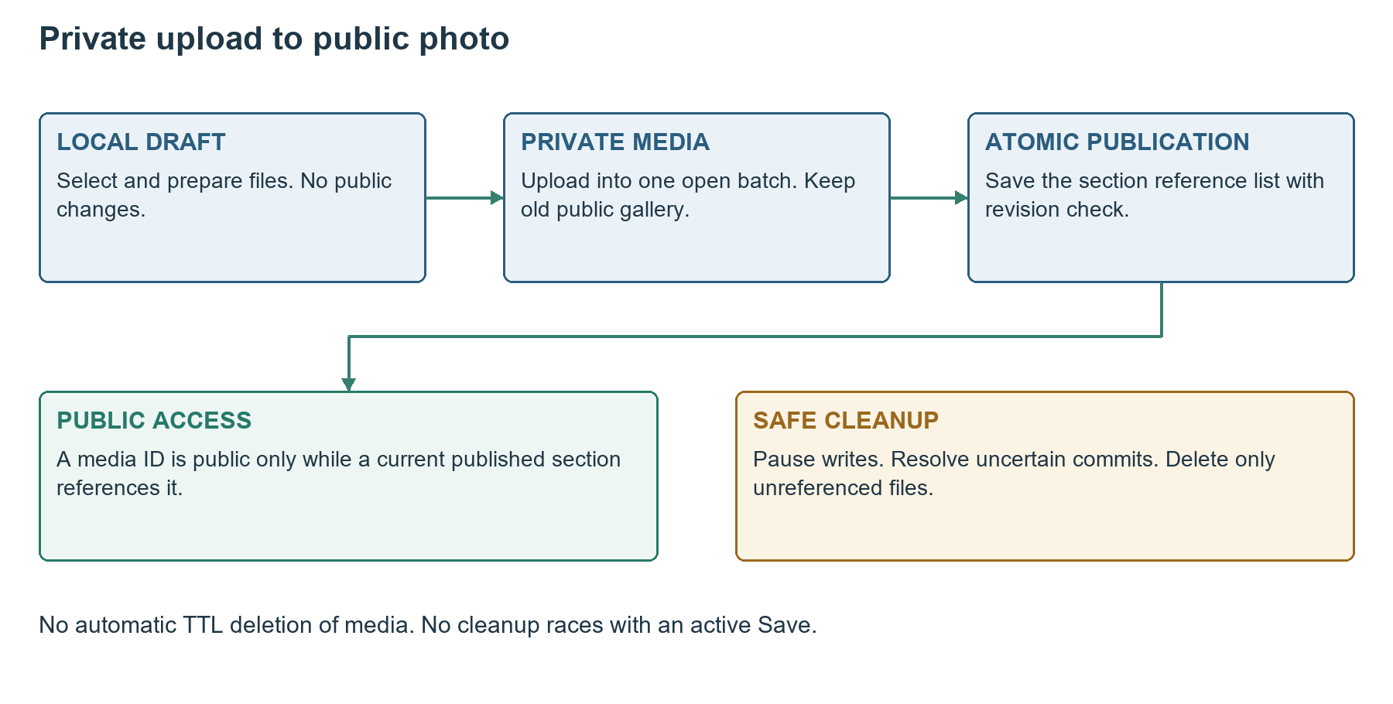
Figure 2 One public reference commit after private file preparation

13.1 Welcome QR and committee photos
Use the same batch and file-upload routes with scope welcome, donation or committee. After staging, PUT the full section value with mediaBatchId and the new media references. Welcome and donation allow one staged replacement per batch; committee allows its bounded member-photo count. These files do not consume the 30-photo gallery allowance.
Keep the existing public image until its section Save succeeds. The server rejects another section's staged file. A removed or replaced reference becomes cleanup-eligible only after commit. The payment QR uses the same file validation and must remain scannable; validate the real QR destination manually before release.

13.2 Cancel before and after a partial transfer
Before Save, Cancel only discards local draft files and edits. With no active request, an interrupted Save can be cancelled after resolving the section operation; abandon its private batch if the section did not commit. No endpoint removes the existing public gallery as a side effect. Physical cleanup is performed later with writes paused.
A three-hour session expiry preserves the draft in browser memory and asks for sign-in. Resume only an unexpired batch, recheck the current revision and require an explicit Save. A full browser reload can lose the draft, so use the agreed unsaved-navigation warning. No persistent draft history is added.

14 Error Catalogue and Validation Paths
HTTP | Code | Meaning and required handling
400 | BAD_REQUEST | Malformed JSON, invalid UUID or invalid query shape
401 | AUTH_REQUIRED | No valid admin session; preserve draft and sign in
401 | SESSION_EXPIRED | Known expired session; same UI recovery as AUTH_REQUIRED
401 | INVALID_CREDENTIALS | Generic wrong email or password
403 | ORIGIN_REJECTED or CSRF_REJECTED | Reject mutation without changing content
404 | NOT_FOUND or MEDIA_NOT_FOUND | Unknown route, item or non-public image
409 | REVISION_CONFLICT | Newer target snapshot; return currentRevision
409 | LINKED_CONTENT_CONFLICT | Programme/puja relationship would become invalid
409 | IDEMPOTENCY_KEY_REUSED or FILE_KEY_REUSED | Same retry identity with different intended data
409 | GALLERY_LIMIT_REACHED | Final gallery exceeds 30; prior gallery unchanged
409 | STAGING_LIMIT_REACHED | Open batch or private byte allowance exhausted
410 | BATCH_UNAVAILABLE | Expired or abandoned batch cannot accept new work
413 | PAYLOAD_TOO_LARGE | Application or hosting request limit exceeded
415 | UNSUPPORTED_MEDIA_TYPE | Wrong JSON content type or image output format
422 | VALIDATION_FAILED or INVALID_IMAGE | Input or decoded file fails the declared contract
429 | SIGN_IN_THROTTLED | Wait Retry-After seconds before another attempt
500 | INTERNAL_ERROR | Unexpected failure; log request ID without secrets
503 | SERVICE_UNAVAILABLE | Database, capacity or temporary service failure

A hosting-generated 413 or infrastructure error may not use the JSON envelope. The browser must handle non-JSON errors and retain its draft. A write timeout can have an uncertain commit result; the message must not assert that nothing was saved. Resolve the operation ID before retrying.

14.1 Field error detail
Use fieldErrors entries {path, code, householdId? or itemId?}. Paths are dot-separated, for example value.households.2.name.te or value.items.0.alt.en. Stable IDs let the UI locate a row after search or sorting. Return a bounded set of at most 100 errors with truncated true when more exist; reject the whole submission, never save the valid subset.

15 Security Caching and Acceptance Checks

15.1 Protected request processing
Check same origin, active account and absolute session expiry for every protected mutation, including uploads and final publication. Validate the CSRF header against the cookie and private session digest. Verify expiry again immediately before entering the persistence write or transaction. Activity, uploads and successful reads do not extend the three-hour deadline. [A3]
Use strict request allowlists, safe text rendering, no-store JSON responses, Secure host-only cookies and server-only database configuration. No secrets use NEXT_PUBLIC_. Do not log credential bodies, CSRF values, cookies or entire household drafts. Record request IDs and outcome codes. Public account details are never returned.
Verification | Pass condition
Signed-out Edit | Opens sign-in and returns to the same target section afterward
Direct public write | 401 or 403; saved data remains unchanged
Three-hour expiry | Protected action rejects and preserves the local draft
One Chandas Save | All rows submitted; no hidden search rows lost
Contribution replacement | Entering INR 1500 stores 150000 and adjusts total once
No history | No old amount in records or technical receipts
Bad row | 422; all prior public rows, total and timestamp intact
Old tab | 409; no automatic overwrite
Uncertain reply | Operation read or exact retry resolves without duplicate commit
Gallery Save | Private transfers followed by one complete reference commit
Newest first | Last selected new image first; retained images keep order
31st photo | Rejected without affecting the existing gallery
Private staging | Public image request is 404 before publication
Production isolation | Preview/test credentials cannot change production or Make My Marriage

Run integration tests against isolated database fixtures and representative iPhone and Android images. Test non-JSON hosting errors, a network interruption after commit, stale revisions, duplicate file retries and expiry between the final upload and publication. Do not create test contributions in production.

16 End to End Implementation Sequence

16.1 Chandas interaction
- Visitor selects Edit. Check session; if needed, sign in through the popup and retain the intended section.
- GET the full admin Chandas snapshot, open one draft and edit names or current totals.
- On Save validate the full draft, generate an operation ID and PUT all rows with the expected revision.
- On confirmed success replace the entire public view and close editing; otherwise retain the draft and follow the error contract.

16.2 Gallery interaction
- GET the admin gallery snapshot and open one editor. Select photos and assign persistent local selection IDs and indexes.
- On the one Save action, create or resume a batch, prepare each file and upload sequentially.
- PUT the full gallery value with the uploaded IDs, original revision and one operation ID.
- Resolve uncertain results; close editing only after successful publication. Cancel discards the local draft and can abandon uncommitted staging.

16.3 Engineering handoff
Implement the schemas and index definitions in Database Design V1 first, then shared authentication, projections and domain validation, followed by these handlers and UI integration. Keep the endpoint catalogue, shared types and examples consistent when adding implementation details. No application implementation is included in these documents.
Release requires a production read, administrator sign-in, full Chandas Save, current-total correction, gallery publication, public image read and sign-out, plus a verified private backup. Content names, programme timings, QR and Maps location remain organiser-supplied and reviewed.

16.4 Primary technical references
Documentation checked on 15 October 2026. Platform constraints and dependency compatibility must be rechecked before release.
A1 Next.js backend for frontend guidance
A2 Vercel Function payload limits
A3 OWASP CSRF prevention guidance
A4 MongoDB atomic writes and revision filters

